Electronic Card Access for College of Agricultural Sciences
To start the process for obtaining building card access, contact your departmental Access Coordinator and have a card access only request submitted for the building(s) to which you need access. Once submitted, you will receive a confirmation email like this:
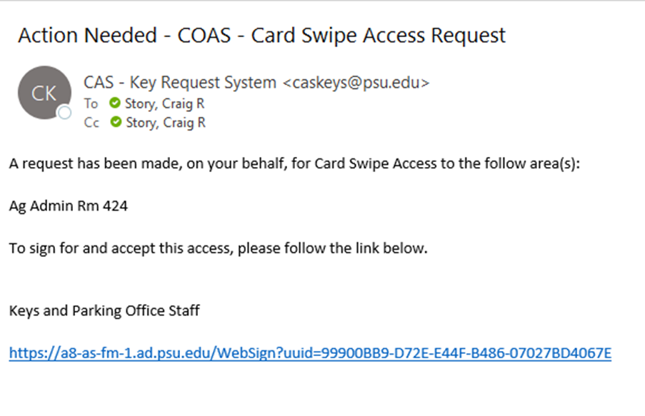
Click on the link at the bottom of the email from any computer or mobile device to access the signature page. It will bring you to the following page:
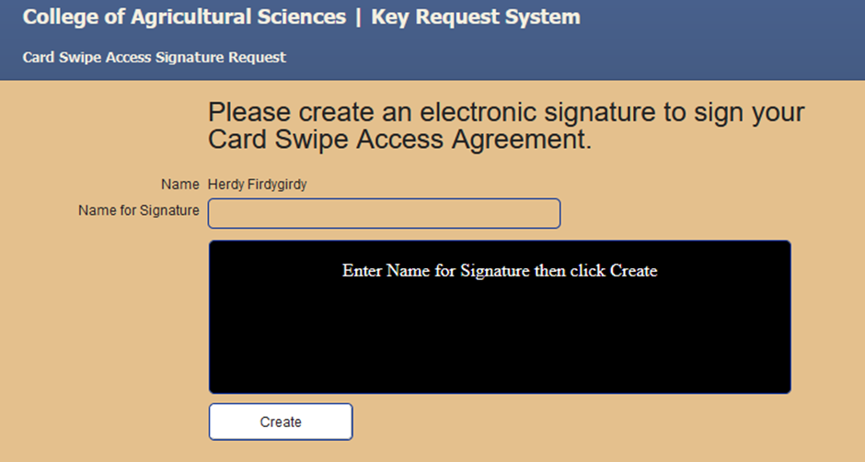
Type your name in the box under your preprinted name just as if you were signing with pen and paper and click on Create. Your generated signature will appear in the box like this:
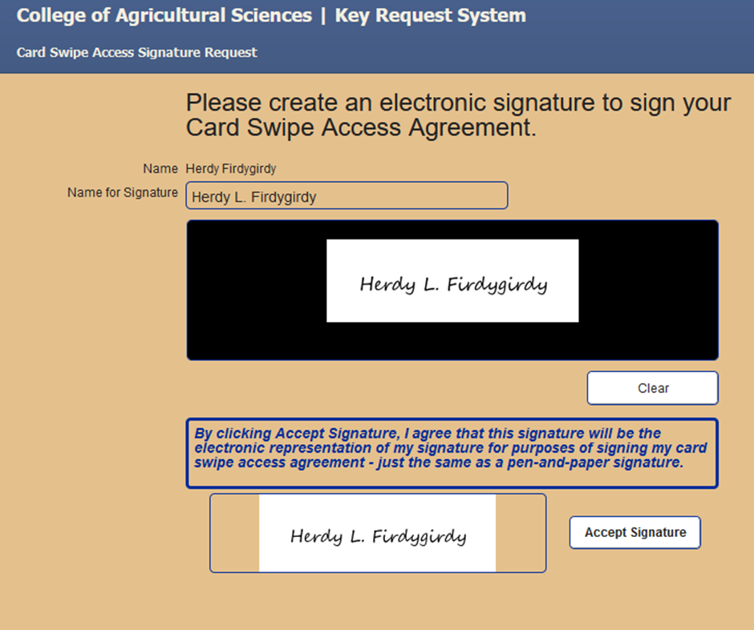
Click on the box that says Accept Signature. This will bring you to a review screen like this:
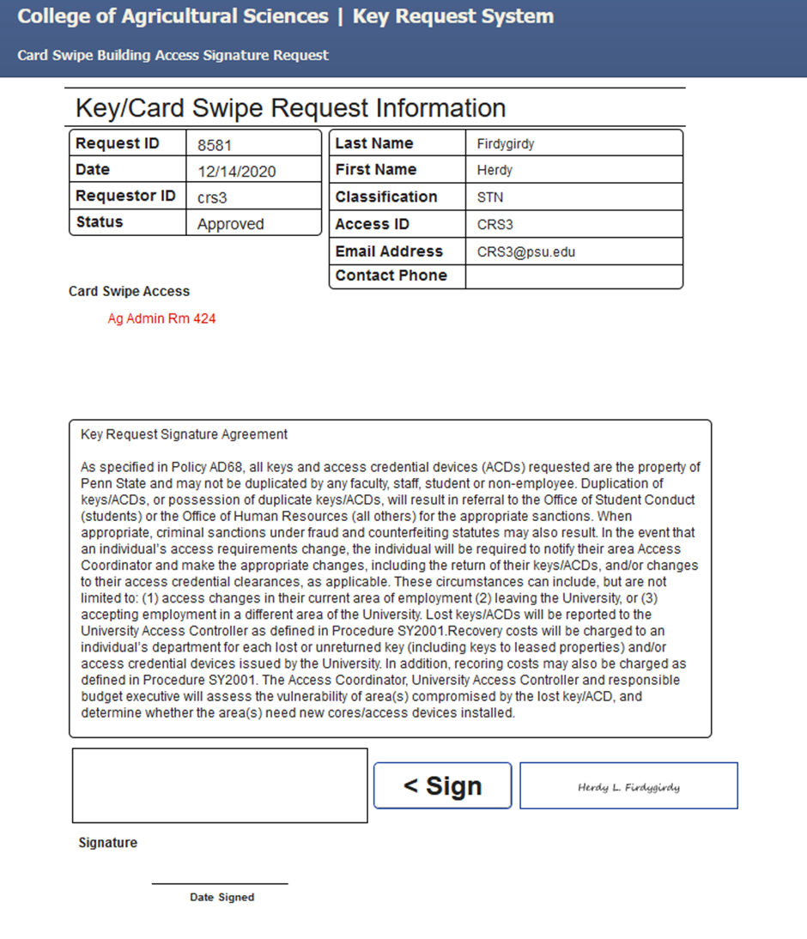

Click on Sign and you are done! The Keys and Parking Office will receive your signed request and will grant the requested building card access within 24 hours.

